18B Dawn of a New Day Mass Casualty Incident Full Scale and Functional Exercise (FSE/FE)

Exercise Plan (ExPlan)
Involved Facilities:
Springfield Regional Medical Center
Mercy Health Urbana Hospital

Exercise Date: Thursday, October 4, 2018
The Exercise Plan (ExPlan) gives elected and appointed officials, observers, media personnel, and players from participating organizations information they need to observe or participate in the exercise. Some exercise material is intended for the exclusive use of exercise planners, controllers, and evaluators, but players may view other materials that are necessary to their performance. All exercise participants may view the ExPlan.
Version Update: September 2018

Exercise Overview
Exercise Name | Dawn of a New Day Mass Casualty Incident, Full Scale Exercise, and Functional Exercise
Exercise Dates | Oct 4, 2018
Address | Springfield Regional Medical Center  100 Medical Center Dr  Springfield, OH, 45504  Mercy Health Urbana Hospital  904 Scioto St  Urbana, OH, 43078
Scope | This exercise is a Full Scale and Functional Exercise, planned for 3.5 hours at Springfield Regional Medical Center in Springfield, Ohio and Mercy Health Urbana Hospital in Urbana, Ohio. Exercise play is limited to the role hospitals and first responders have in response to an active shooter, mass casualty incident.

Mission Area(s) | Response
Funding | This is a non-funded exercise.

Core Capabilities | - Planning  - Communications  - Responder Safety and Health  - Emergency Public Safety and Security  - Emergency Triage and Pre-Hospital Treatment  - Medical Surge  - Community Preparedness & Participation  - On-site Incident Management
Objectives | Exercise design objectives focus on improving understanding of a response concept, identifying opportunities or problems, and achieving a change in attitude. This exercise will focus on the following design objectives selected by the Exercise Planning Team:  - Foundation for Health Care and Medical Readiness. Assess plans and capabilities governing on-scene command, the Hospital Command Center (HCC), and Unified Command (UC). Determine capabilities to coordinate and integrate diverse response resources, establish adequate medical surge, and effectively track patients. Assess the ability to establish and maintain both internal and multiagency communications in response to an active shooter, terrorist, or other major mass casualty incident (MCI). Identify critical issues and potential solutions.  - Health Care and Medical Response Coordination. Asses the activation and utilization of plans and coordination through effective communication: on scene, from scene to hospital, within the hospital, and with other major personnel, hospitals, and agencies. Examine the ability of the staff to activate and monitor all hospital response systems. Assess the ability of the hospital to effectively triage and coordinate appropriate medical and surgical care. Determine the ability of the hospital to mobilize resources and staff to any necessary location. Utilize tools that allow for effective patient tracking. Ensure effective security measures are taken within the hospital. Identify critical issues and potential solutions to those issues.  - Continuity and Health Care Service Delivery. Assess logistics, emergency procurement, and distribution of critical resources, and the impacts of delays. Determine that potential evidence of the incident would be preserved for law enforcement. Assess management of patient lab/imaging results. Assess allocation of resources for expectant patients. Determine the ability to manage deceased victims. Examine procedures to assist patients after discharge and policies regarding communication with families. Identify critical issues and potential solutions. Determine shortcomings in local medical and surgical capabilities to treat casualties resulting from a terrorist incident. Assess patient tracking capabilities.  4. Medical Surge. Assess the ability to implement surge plans. Assess strategies used to enhance capacity in a stressed environment. Identify critical issues and potential solutions to those issues.
Threat or Hazard | Active Shooter Terrorism Incident with Improvised Explosive Device (IED).
Scenario | Man enters Springfield Reginal Medical Center and begins shooting patients, visitors, and faculty. A 15-lb IED explodes following the initial response. Numerous victims with some fatalities.
Sponsor | Southwest Ohio Regional Trauma System (SORTS), Greater Dayton Area Hospital Association (GDAHA), Dayton Metropolitan Medical Response System (DMMRS), and Mercy Health
Participating Organizations | Springfield Regional Medical Center  Springfield Police Department  Springfield Fire Rescue Division  Greater Dayton Area Hospital Association  Southwest Ohio Regional Trauma System  Dayton Metropolitan Medical Response System  Mercy Urbana Hospital  Multiple other Law Enforcement and EMS
Point of Contact | Exercise Director:  Kaiti Overholser  Emergency Management Coordinator  Mercy Health – Springfield Market  koverholser@mercy.com  (937) 523-1463  Senior Controller and MMRS POC:David N. Gerstner  MMRS/RMRS/EP Coordinator  Dayton Fire Department  300 N. Main St.  Dayton, Ohio 45402  Office: 937-333-4551  FAX: 937-333-4561  24/7 Pager: 937-227-8705 or E-mail 9372278705@archwireless.net  E-Mail: david.gerstner@daytonohio.gov  http://DaytonMMRS.org

General Information

Purpose
The “Dawn of a New Day” Exercise Series (Tabletop [TTX] followed by Full-Scale [FSE] with Functional Exercise [FE] elements) was developed by GDAHA, SORTS, and by the Hospital and Healthcare Security during Mass Casualty Incidents Committee. The latter is a joint committee of Greater Dayton Area Hospital Association (GDAHA) and Dayton Metropolitan Medical Response System (MMRS), and is often referred to as the “Mumbai Committee,” so named because of the 2008 incident perpetrated by Lashkar-e-Taiba in Mumbai, India during which one of the targets was Cama and Albless Hospital. The exercise and materials were produced with input, advice, and assistance from the Exercise Planning Team, which followed guidance set forth by the U.S. Department of Homeland Security (DHS) Homeland Security Exercise and Evaluation Program (HSEEP).

The purpose of this exercise is to provide participants with an opportunity to evaluate current response concepts, plans, and capabilities for a response to an Active Shooter/Terrorist Incident. The exercise focuses on local emergency response, command and control/coordination, critical decisions, notifications, and integration of hospital, regional, and local assets necessary to save lives and protect public health and safety. The role of public information strategies is discussed as a critical component to the overall response effort.
Exercise Objectives and Core Capabilities
The following exercise objectives in Table 1 (page 5) describe the expected outcomes for the exercise. The objectives are linked to Hospital Preparedness Program (HPP) capabilities and target capabilities, which are distinct critical elements necessary to achieve the specific mission area(s). The objectives and aligned target capabilities are guided by elected and appointed officials and selected by the Exercise Planning Team.

Objective | HPP Capabilities Addressed | Target Capabilities
Assess plans and capabilities governing on-scene command, the Hospital Command Center (HCC), and Unified Command (UC). Determine capabilities to coordinate and integrate diverse response resources, establish adequate medical surge, and effectively track patients. Assess the ability to establish and maintain both internal and multiagency communications in response to an active shooter, terrorist, or other major mass casualty incident (MCI). Identify critical issues and potential solutions. | Foundation for Health Care and Medical Readiness | Planning  Communications  Community Preparedness and Participation  On-Site Incident Management
Asses the activation and utilization of plans and coordination through effective communication: on scene, from scene to hospital, within the hospital, and with other major personnel, hospitals, and agencies. Examine the ability of the staff to activate and monitor all hospital response systems. Assess the ability of the hospital to effectively triage and coordinate appropriate medical and surgical care. Determine the ability of the hospital to mobilize resources and staff to any necessary location. Utilize tools that allow for effective patient tracking. Ensure effective security measures are taken within the hospital. Identify critical issues and potential solutions to those issues. | Health Care and Medical Response Coordination | Communications  Responder Safety and Health  Triage and Pre-Hospital Treatment
Assess logistics, emergency procurement, and distribution of critical resources, and the impacts of delays. Determine that potential evidence of the incident would be preserved for law enforcement. Assess management of patient lab/imaging results. Assess allocation of resources for expectant patients. Determine the ability to manage deceased victims. Examine procedures to assist patients after discharge and policies regarding communication with families. Identify critical issues and potential solutions. Determine shortcomings in local medical and surgical capabilities to treat casualties resulting from a terrorist incident. Assess patient tracking capabilities. | Continuity and Health Care Service Delivery | Responder Safety and Health  Emergency Public Safety and Security  Medical Surge
Assess the ability to implement surge plans. Assess strategies used to enhance capacity in a stressed environment. Identify critical issues and potential solutions to those issues. | Medical Surge | Planning  Medical Surge
Table 1. Exercise Objectives and Associated Core Capabilities

Participant Roles and Responsibilities
The term participant encompasses many groups of people, not just those playing in the exercise. Groups of participants involved in the exercise, and their respective roles and responsibilities, are as follows:
- Players. Players are personnel who have an active role in discussing or performing their regular roles and responsibilities during the exercise. Players discuss or initiate actions in response to the simulated emergency.
- Controllers. Controllers plan and manage exercise play, set up and operate the exercise site, and act in the roles of organizations or individuals that are not playing in the exercise. Controllers direct the pace of the exercise, provide key data to players, and may prompt or initiate certain player actions to ensure exercise continuity. In addition, they issue exercise material to players as required, monitor the exercise timeline, and supervise the safety of all exercise participants.
- Evaluators. Evaluators evaluate and provide feedback on a designated functional area of the exercise. Evaluators observe and document performance against established capability targets and critical tasks, in accordance with the Exercise Evaluation Guides (EEGs). For purposes of this exercise, all Evaluators will serve jointly as Controllers.
- Simulators. Simulators are control staff personnel who role play nonparticipating organizations or individuals. They most often operate out of the Simulation Cell (SimCell), but they may occasionally have face-to-face contact with players. Simulators function semi-independently under the supervision of SimCell controllers, enacting roles (e.g., media reporters or next of kin) in accordance with instructions provided in the Master Scenario Events List (MSEL). All simulators are ultimately accountable to the Exercise Director and Senior Controller.
- Actors. Actors simulate specific roles during exercise play, typically victims or other bystanders.
- Observers. Observers visit or view selected segments of the exercise. Observers do not play in the exercise, nor do they perform any control or evaluation functions. Observers view the exercise from a designated observation area and must remain within the observation area during the exercise. Very Important Persons (VIPs) are also observers, but they frequently are grouped separately.
- Media Personnel. Some media personnel may be present as observers, pending approval by the sponsor organization and the Exercise Planning Team.
- Support Staff. The exercise support staff includes individuals who perform administrative and logistical support tasks during the exercise (e.g., registration, catering).

Exercise Assumptions and Artificialities
In any exercise, assumptions and artificialities may be necessary to complete play in the time allotted and/or account for logistical limitations. Exercise participants should accept that assumptions and artificialities are inherent in any exercise, and should not allow these considerations to negatively impact their participation.

Assumptions
Assumptions constitute the implied factual foundation for the exercise and, as such, are assumed to be present before the exercise starts. The following assumptions apply to the exercise:
- The exercise is conducted in a no-fault learning environment wherein capabilities, plans, systems, and processes will be evaluated.
- The exercise scenario is plausible, and events occur as they are presented.
- Exercise simulation contains sufficient detail to allow players to react to information and situations as they are presented as if the simulated incident were real.
- Participating agencies may need to balance exercise play with real-world emergencies. Real-world emergencies take priority.
- All players receive information at the same time.
- There is no hidden agenda, and there are no trick questions.
- Players will respond in accordance with their agencies or department’s plans, policies, processes, and procedures, and their best professional judgment as if this were a real event.
- Simulation during the exercise may be required to compensate for nonparticipating individuals or organizations and time constraints.
- Exercise simulation will be as realistic and plausible as possible in the exercise.
- Systems such as WENS, OHTrac, GDAHA Surgenet, hospital paging and notification systems, overhead paging and the Regional Hospital Notification System are available for use during the exercise.

Artificialities
During this exercise, the following artificialities apply:
- All electronic exercise communications will begin and end with the words “THIS IS AN EXERCISE”.
- In recognition of the presence of patients and visitors who could misunderstand, Players are encouraged to use the phrase “THIS IS AN EXERCISE” even with face-to-face conversations.
- Exercise Players will not contact outside agencies except those listed in Appendix B: Exercise Participants/Player Directory.
- A SIMCELL will play the part of non-playing private citizens, local government, state and federal government, the media and other non-playing organizations. Do NOT make calls to non-playing agencies; call the SIMCELL.
- Exercise players placing telephone calls or initiating radio communication with the SIMCELL must identify the organization, agency, office, or individual with whom they wish to speak.
- Participating agencies may need to balance exercise play with real-world emergencies. It is understood that real-world emergencies will take priority. In the event of a “Real World Emergency” play will be stopped with the words “This is a Real World Emergency”.
- Exercise play will begin with a STARTEX message from the Senior Controller.

Exercise Logistics

Safety
Exercise participant and real-world patient safety takes priority over exercise events. The following general requirements apply to the exercise:
- A Safety Controller is responsible for participant safety; any safety concerns must be immediately reported to the Safety Controller or other Controller. The Safety Controller, Senior Controller and Exercise Director will determine if a real-world emergency warrants a pause in exercise play and when exercise play can be resumed.
- For an emergency that requires assistance, use the phrase “real-world emergency.” The following procedures should be used in case of a real emergency during the exercise:
- Anyone who observes a participant who is seriously ill or injured will immediately notify emergency services and the closest controller, and, within reason and training, render aid.
- The controller aware of a real emergency will initiate the “real-world emergency” broadcast and provide the Safety Controller, Senior Controller, and Exercise Director with the location of the emergency and resources needed, if any. The Senior Controller will notify the SimCell as soon as possible if a real emergency occurs.

Fire Safety
Standard fire and safety regulations will be followed during the exercise. Springfield Fire Division will be on site throughout the exercise and will immediately respond to any alarms or real-word emergencies.

Emergency Medical Services
The sponsor organization will coordinate with local emergency medical services in the event of a real-world emergency. Springfield Fire Division and other Emergency Medical Service agencies will be on site throughout the exercise and will immediately respond to any alarms or real-word emergencies. Public safety apparatus will stage in the Employee Parking Lot at Springfield Regional Medical Center. See Appendix D for road map.

Weapons Policy
All participants will follow the relevant weapons policy for the exercising organization or exercise venue. See Appendix E for a detailed description of the weapons policy.

Site Access

Security
Site security is the responsibility of Springfield Regional Medical Center Security, Mercy Urbana Hospital. To prevent interruption of the exercise, access to some exercise sites and the SimCell is limited to exercise participants. Players should advise their venue’s controller or evaluator of any unauthorized persons. At the same time, all personnel must remember that all areas of the hospital will continue normal operations during the exercise.

Media/Observer Coordination
Organizations with media personnel and/or observers attending the event should coordinate with the Media Liaison personnel from Mercy Health for access to the exercise site. Media/Observers are escorted to designated areas and accompanied by an exercise controller or liaison personnel at all times. Sponsor organization representatives and/or the observer controller may be present to explain exercise conduct and answer questions. Exercise participants should be advised of media and/or observer presence.

Exercise Identification
Exercise staff may be identified by badges, hats, and/or vests to clearly display exercise roles; additionally, uniform clothing may be worn to show agency affiliation. Table 2 describes these identification items.
Group | Color
Exercise Director | White
Senior Controller | White
Controllers/Evaluators | Blue
Controllers | Red
Evaluators | Blue
Actors | Black
Support Staff | Gray
Observers/VIPs | Orange
Media Personnel | Purple
Players, Uniformed | Yellow
Players, Civilian Clothes | Yellow

Table 2. Exercise Identification

Registration
All exercise participants will register on designated forms that will be provided to each exercise area.

Post-exercise and Evaluation Activities

Debriefings
Post-exercise debriefings aim to collect sufficient relevant data to support effective evaluation and improvement planning.

Hot Wash

At the conclusion of exercise play, Controllers at each area facilitate a Hot Wash to allow players to discuss strengths and areas for improvement, and evaluators to seek clarification regarding player actions and decision-making processes. All participants may attend; however, observers are not encouraged to attend the meeting. The Hot Wash should not exceed 30 minutes, and will be held by each Controller/Evaluator at each location. Controllers will distribute Participant Feedback forms and encourage participants to file them electronically, or collect the paper copes and return those to the Senior Controller.Participant Feedback Forms
Participant Feedback Forms provide players with the opportunity to comment candidly on exercise activities and exercise design. Participant Feedback Forms should be collected at the conclusion of the Hot Wash. If people are doing them on paper, please encourage all participants to file them electronically; Instructions to do so are on the forms.

Evaluation

Exercise Evaluation Guides (EEGs)
EEGs assist evaluators in collecting relevant exercise observations. EEGs document exercise objectives and aligned core capabilities, capability targets, and critical tasks. Each EEG provides evaluators with information on what they should expect to see demonstrated in their functional area. The EEGs, coupled with Participant Feedback Forms and Hot Wash notes, are used to evaluate the exercise and compile the After-Action Report (AAR). Controllers should use the paper EEGs for notes, then submit their comments electronically using the URL or QR code included on the EEG.

After-Action Report
The AAR summarizes key information related to evaluation. The AAR primarily focuses on the analysis of capabilities and objectives, including capability performance, strengths, and areas for improvement. AARs also include basic exercise information, including the exercise name, type of exercise, dates, location, participating organizations, mission area(s), specific threat or hazard, a brief scenario description, and the name of the exercise sponsor and POC.

Improvement Planning
Improvement planning is the process by which the observations recorded in the AAR are resolved through development of concrete corrective actions, which are prioritized and tracked as a part of a continuous corrective action program.

Improvement Plan
The IP identifies specific corrective actions, assigns them to responsible parties, and establishes target dates for their completion. It is created by the Exercise Planning Team.

Participant Information and Guidance

Exercise Rules
The following general rules govern exercise play:
- Real-world emergency actions take priority over exercise actions.
- Exercise players will comply with real-world emergency procedures, unless otherwise directed by the control staff.
- All communications inside the hospital (including written, radio, telephone, e-mail, and to the extent feasible, oral communications) during the exercise will begin and end with the statement “This is an exercise.” The use of this phrase between participants during conversation is advised due to the ongoing real world hospital operations.
Exercise players who place telephone calls or initiate radio communication with the SimCell must identify the organization or individual with whom they wish to speak.

Players Instructions
Players should follow guidelines before, during, and after the exercise to ensure a safe and effective exercise.

Before the Exercise
- Review appropriate organizational plans, procedures, and exercise support documents.
- Be at the appropriate site at least 30 minutes before the exercise starts or as otherwise directed. Wear the appropriate uniform and/or identification item(s).
- Sign in when you arrive.
- If you gain knowledge of the scenario before the exercise, notify a controller so that appropriate actions can be taken to ensure a valid evaluation.

During the Exercise
- Respond to exercise events and information as if the emergency were real, unless otherwise directed by an exercise Controller.
- Controllers will give you only information they are specifically directed to disseminate. You are expected to obtain other necessary information through existing emergency information channels.
- Do not engage in personal conversations with controllers, evaluators, observers, or media personnel. If you are asked an exercise-related question, give a short, concise answer. If you are busy and cannot immediately respond, indicate that, but report back with an answer as soon as possible.
- If you do not understand the scope of the exercise, or if you are uncertain about an organization’s participation in an exercise, ask a controller.
- Parts of the scenario may seem implausible. Recognize that the exercise has objectives to satisfy and may require incorporation of unrealistic aspects. Every effort has been made by the exercise’s trusted agents to balance realism with safety and to create an effective learning and evaluation environment.
- All exercise communications will begin and end with the statement “This is an exercise” This precaution is taken so that anyone who overhears the conversation will not mistake exercise play for a real-world emergency.
- When you communicate with the SimCell, identify the organization or individual with whom you wish to speak.
- Speak when you take an action. This procedure will ensure that evaluators are aware of critical actions as they occur.
Maintain a log of your activities. Many times, this log may include documentation of activities that were missed by a controller or evaluator.
All spoken and written communications will start and end with
“THIS IS AN EXERCISE.”

After the Exercise
- Participate in the Hot Wash at your venue with controllers and evaluators.
- Complete the Participant Feedback Form. This form allows you to comment candidly on emergency response activities and exercise effectiveness. Provide the completed form to a controller or evaluator.
Provide any notes or materials, especially forms, generated from the exercise to your controller or evaluator for review and inclusion in the AAR.

Simulation Guidelines
Because the exercise is of limited duration and scope, certain details will be simulated. The physical description of what would fully occur at the incident sites and surrounding areas will be relayed to players by simulators or controllers. A SimCell will simulate the roles and interactions of nonparticipating organizations or individuals. All EMS transports will only go from simulated incident scene to SRMC.

Progressive Information Envelopes
For this exercise, “Progressive” patient info will be available in multiple envelopes (Green, Orange, Yellow Pink and Purple) and will be kept with victims throughout the exercise. Each envelope is marked in LARGE letters, “Do NOT open until victim has been in ____ (ED, OR, etc.) for at least ___ minutes”. Progressive Info also includes imaging and lab results (Purple envelopes) for selected patients, which will prompt some surgical decision-making.

Envelope Categories and Rules:
We use several different colors and sizes of envelope for this exercise: Green, Orange, Yellow, and Pink. C/Es should watch to be sure envelopes are used as directed.

- Green envelopes have baseline information on the front for RTF personnel, and a set of vitals for cold zone EMS inside.
- Orange envelopes have an additional set of vitals inside but cannot be opened until the patient has been in the ED 5 minutes.
- Yellow envelopes contain an additional set of vitals and cannot be opened until the patient has been in the hospital for 20 minutes.
- Pink envelopes are to be opened exclusively by OR personnel. Inside this envelope is a form that will need to be filled out for each pt. that arrives in the operating suite.

Using Equipment:
There is also a large, Purple envelope labeled “Resources.” That can be used in the ED, the OR, or anywhere in the hospital. It contains:
- A “Treatment Card”
- A page of stickers for treatments and procedures
- A “Lab Order Sheet”
- An “Imaging Order Sheet”
All of these will have the patient’s name and reference number. When equipment or supplies are used, players are to bring the equipment to the patient, so that it is not available to other patients. Players should also take a sticker from the patient’s sheet and attach it to their treatment card.

Ordering Labs and Imaging:
When ordering labs or imaging, options should be selected on the order form, and then taken to the respective department. When ready, patient results will be returned to players in a large, white envelope. Items from Purple and White envelopes are to be kept with the patient so other departments can use the resources as well.

Information about Progressive Info will also be included in Player Prebriefing and Controller/Evaluator Briefing slideshows.

Full-Scale vs. Functional Exercise Aspects
Initial aspects of the exercise will be “full scale,” meaning that participants will see and hear things they are expected to react to, and should respond directly and in a realistic manner. As exercise play moves into the hospital areas other than the ED and OR, some aspects transition to a functional exercise, meaning that you will communicate, but not actually act. For example, many off-duty personnel will be called, but told not to physically respond. As another example, certain laboratory tests may be ordered, but there will not actually be samples to test. In those situations, personnel should take all steps as if they were to actually test a specimen, including documentation and reporting of simulated results.
When in doubt about how to respond, ask a Controller or contact SimCell.

Issues Related to Play in a Functioning Hospital
Springfield Regional Medical Center and Mercy Health Urbana Hospital are taking steps to reduce concerns of non-playing personnel, patients, visitors, and staff. All players should respect and make use of all appropriate steps.
- Clear signage will be posted, with statements such as “Mass Casualty Incident Exercise in Process – Do Not Be Concerned.” SRMC and Mercy Urbana will post signage.
- Media have been advised of the exercise, and invited to observe and film. The Mercy Health Public Information Officer (PIO) will be on site. Media will only be inside the hospital when accompanied by Mercy Health Media Relations. If there are real world patient privacy concerns, immediately bring them to the attention of the PIO or a Controller.
- Hospital personnel throughout the organization are being informed about the exercise. There will be signage around and outside of the hospital.
- All players, especially non-hospital personnel (e.g., fire, EMS, law enforcement) must be cognizant of hospital issues and concerns.
- Notifications will be used to reduce concerns. In addition to pre-exercise information disseminated via memos and emails to staff and the SIGNAGE discussed above, there will be repeated overhead announcements throughout the exercise saying a drill is being conducted, and there is no danger. Some areas may be isolated using scene tape.
- Be aware that moulage is being used on actors to increase the sense of reality for participants. Some gruesome injuries are being simulated.
- Actors will be wearing “victim tags” that provide information about their injuries and conditions, as well as condition changes. Those seen by EMS personnel will also have Triage Ribbons and Triage Tags applied.
- Progressive” patient info given in multiple envelopes (Green, Orange, Yellow, Pink and Purple) will be kept with victims throughout the exercise. Each envelope is marked with specific instructions regarding what times they should be opened.

- Actors will act as injured victims; however, no invasive procedures (IVs, airway adjuncts, radiological examinations, etc.) are to be performed on victim actors.
- There may also be actors simulating other roles (e.g., family members, press, etc.).
- Again, as often as practical, Players and Controllers should say out loud “This is an exercise.”
- Some players will wear identification, including HICS position vests. Others may wear a vest or identification badge saying, “EXERCISE PLAYER,” “EXERCISE CONTROLLER/EVALUATOR.”

Appendix A: Exercise Schedule
[Note: Because this information is updated throughout the exercise planning process, appendices may be developed as stand-alone documents rather than part of the ExPlan.]
Time | Personnel | Activity | Location
Monday, September 10th
1:00 PM | Controllers, evaluators, and exercise staff | Controller and Evaluator Briefing | Website and Open area at North end of Med/Surg North
Thursday, October 4th, 2018
As needed | Media | Media Briefing | As needed
08:30 AM | Rescue Task Force + LE | Check-in for all LE + RTF personnel | South end of Med/Surg North
08:45 AM | RTF and LE | RTF Briefing | North end of Med/Surg North
09:00 AM | Mercy Victims | Leave for Mercy | Mercy Urbana
09:15 AM | VIPs and selected exercise staff | VIP Controller Briefing | North end of Med/Surg North
09:30 AM | All | Final Check-in for all personnel | Med/Surg North
09:30 AM | LE + RTF | Initial RTF drills (practice run-throughs) | Med/Surg North
09:45 AM | Controllers and evaluators | Controllers and evaluators in starting positions | All playing locations
12:00 PM | Moulagers + Victims | Victim moulaging begins | SRMC
2:00 PM | All | Exercise begins | All playing locations
5:00 PM | All | Exercise ends | All playing locations
Immediately Following the Exercise | All | Venue Hot Washes/turn in all Participant Feedback Forms | All Playing locations

Appendix B: Exercise Participants/Player Directory
Participating Organizations
Simulation Cell (SimCell) Phone Numbers
Use any number, but identify what simulated agency or department you are trying to reach.
SimCell Location: Administrative Conference Room
Springfield Regional Medical Center
Emergency Department (ED) UNDER DEVELOPMENT
Operation Room (OR)
Radiology Department
Respiratory Department
Laboratory Department
Pharmacy
Anesthesia
Blood Bank
Intensive Care Unit (ICU)
Post-Anesthesia Care Unit (PACU)
Environmental Services
Plant Engineering
Security
Hospital Incident Command System (HICS)
Trauma Department
Administration
Springfield Police Division
Springfield Fire Division
Springfield Dispatch
Other
Montgomery County Reginal Dispatch Center (RDC)
Dayton Fire Department
Vandalia FD
Ohio Homeland Security
Franklin Fire Division
Brookville FD
Other EMS Agencies
Ohio State Highway Patrol (OSHP)
Dayton Metropolitan Medical Response System (DMMRS)

Appendix C: Communications Plan

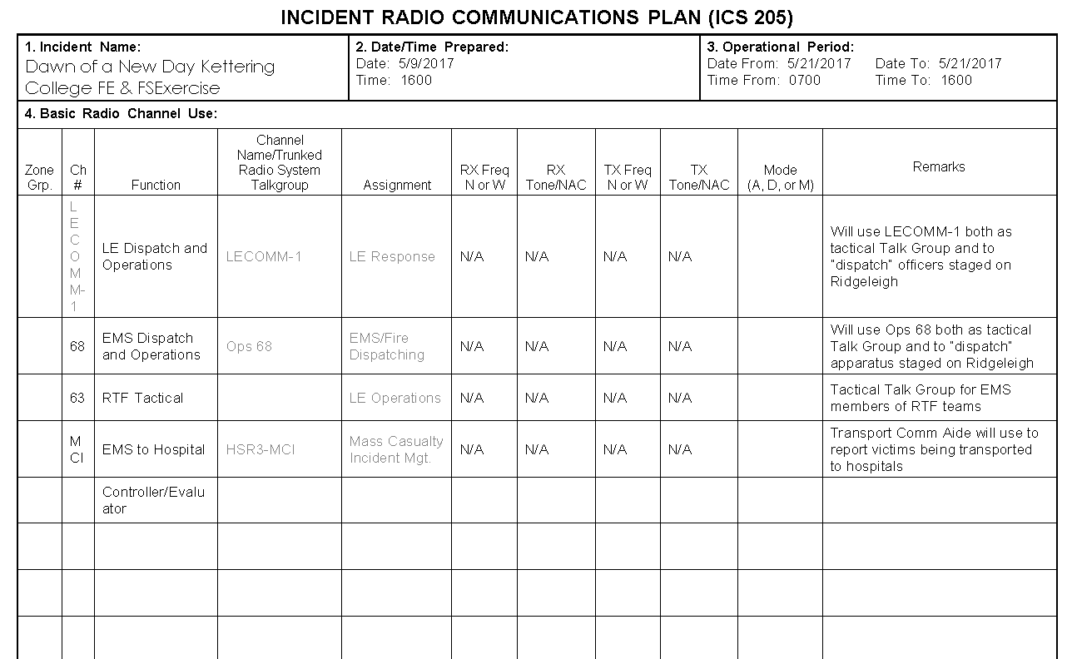

Appendix D: Exercise Site Maps
Figure D.1: Springfield Regional Medical Center parking map
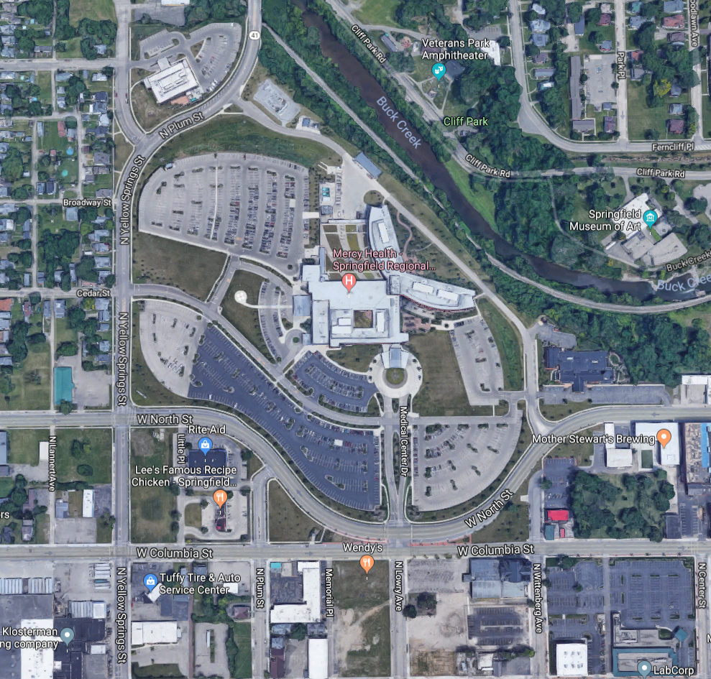


Figure D.2: Springfield Regional Medical Center Parking Map

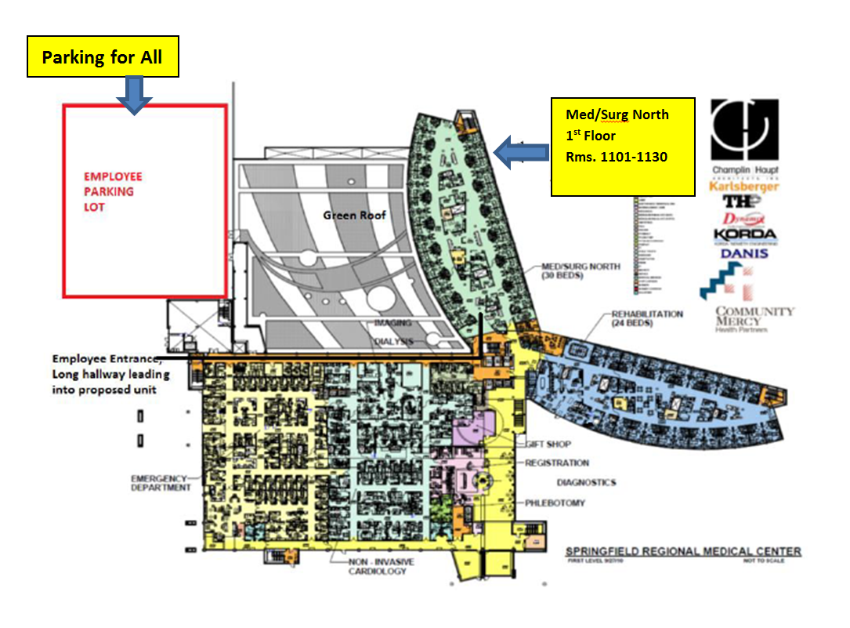
Parking for all participants will be in the employee parking lot.

Appendix E: Weapons Policy
Other than specific training weapons, no weapons of any kind are allowed in the training or exercise area. This includes firearms, ammunition, impact weapons, chemical spray, knives, and electrical weapons (i.e., Tasers).
Approved training weapons will include Simunition firearms and inert blue guns.
Every participant will be searched for unauthorized weapons by safety officers upon entering the training area. If a participant leaves the training area they will be searched upon re-entry.
Simunition weapons safety:
- Barrel stand off for these exercises - five feet from the end of barrel to target
- Rounds may cause cuts, bruising, swelling to areas struck
- Safety gear will be in place when instructors start exercises
- Only instructors will load/unload Simunition weapons
- No horseplay will be tolerated
- Report any injuries to an instructor immediately
- Follow role instructions and do not deviate
- Whistles or the command of cease fire will end the scenario

Appendix F: Acronyms
Acronym | Term
DHS | U.S. Department of Homeland Security
ExPlan | Exercise Plan
HSEEP | Homeland Security Exercise and Evaluation Program
SME | Subject Matter Expert
ED | Emergency Department
OR | Operation Room
ICU | Intensive Care Unit
PACU | Post-Anesthesia Care Unit
HICS | Hospital Incident Command System
WENS | Wireless Emergency Notification System
RDC | Montgomery County Reginal Dispatch Center
OSHP | Ohio State Highway Patrol
GDAHA | Greater Dayton Area Hospital Association
SORTS | Southwest Ohio Regional Trauma System
DMMRS | Dayton Metropolitan Medical Response System

