Memorandum 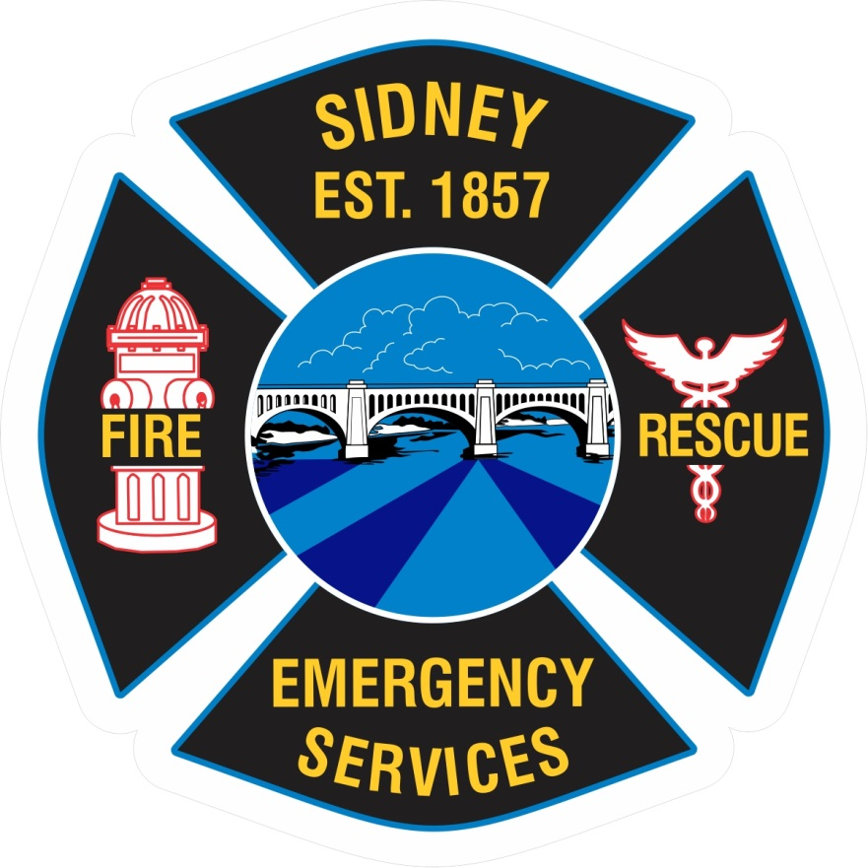
To: All staff
From: Deputy Chief Hollinger
Date: March 13, 2020
Re: COVID-19 screening for employees
In response to concerns regarding COVID-19; always follow universal precautions and PPE instructions.

To ensure that we can quickly and effectively conduct operations and provide confidence to our community partners that we are taking precautions to prevent the spread of COVID-19, we will be implementing screening measures for all staff members of Sidney Department of Fire and Emergency Services.

Effective Tuesday, March 17, 2020 at 0700hrs; all staff and operational members of SDFES will be screened at the start and conclusion of their assigned work period. The screening measures will include:

- Oral temperature assessment
- History or signs/symptoms of respiratory infection (coughing, sore throat, etc…)
- Contact with someone with known or suspected COVID-19

The screening assessment worksheet (SDFES_COVID-19_SCRASMT) and log (SFDES_COVID-19_SCRLOG) will be developed and reviewed prior to implementation. All personal medical information (screening results) will be kept confidential and stored in the care of the Deputy Fire Chief (department Health and Safety Officer). Members facilitating and witnessing screening assessments will keep confidential the findings and results of the screenings.

This order will remain in full force and effect throughout the declaration of a public health emergency related to the COVID-19 outbreak. Due to the fluidity of the information and intelligence provided by local, state and federal health agencies, this order may be amended when guidance directions are adjusted.

Please be diligent in checking department communications (HyperReach, email, etc…) as these channels will be utilized to communicate changes and updates as they become available.

