
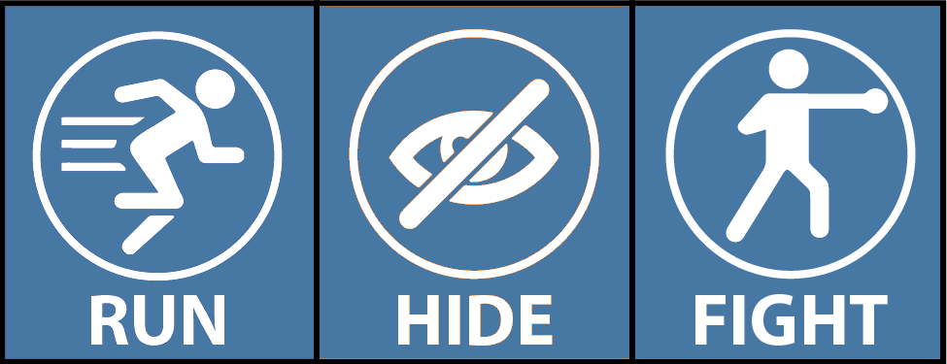


- Notify Hospital Security:

- Call 911
- Report:
  - Location & description of shooter
  - Location & condition of patients
- Warn others!
Communicate:
Run
Hide
Fight
Respond:
Provide guidance and care for patients and others.
Try to secure all critical areas.
If patients can’t be moved, try to block entry.
You have the power to protect.

[HOSPITAL OR FACILITY NAME]
ACTIVE SHOOTER RESPONSE

