

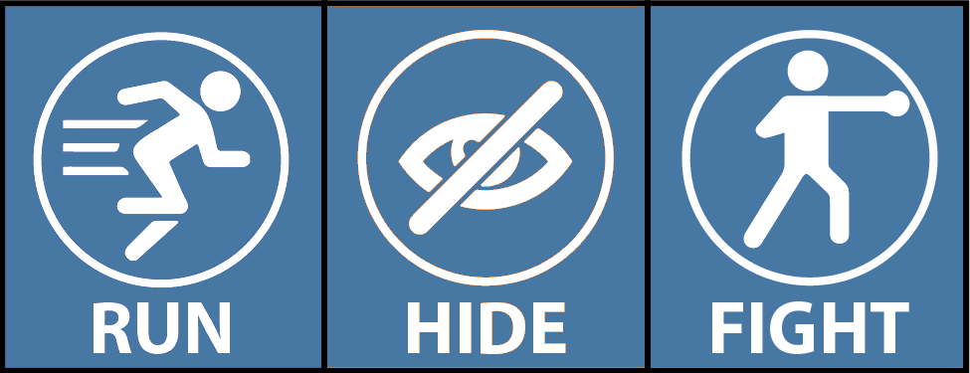

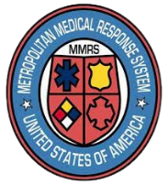
Provide guidance and care for patients and others.
Try to secure all critical areas.
If patients can’t be moved, try to block entry.
You have the power to protect.

- Stay vigilant
- Know the nearest exits
- Review workplace evacuation plans
- Consider optimal safe room location and assets (e.g., first-aid or trauma kits, locking doors, means to barricade)
- Greet individuals with “hello” to detect suspicious behavior
- If you See something suspicious, Say something! (call someone)
- Attend trainings facilitated by your hospital, GDAHA, and MMRS, and review recommended resources such as this Run, Hide,
Fight
Video:
Keep in Mind:
Prepare
and Prevent:
Communicate:
- Notify Hospital Security and call 911:

- Report:
  - Location & description of shooter
  - Location & condition of patients
- Warn others!
Fight
Hide
Run
Respond:
- Law Enforcement throughout our region including hospital law enforcement are trained and committed to aggressively respond to active shooter incidents
- Remain calm & rely on your training
- Help keep others safe
- Call 911 when safe to do so
- Your information helps save lives
HOSPITAL ACTIVE SHOOTER
RESPONSE & PREVENTION GUIDE

